**Probabilistic Interpretation: Gaussian Naive Bayes:**Different ways for logistic regressions  
1) Geometry – It’s already discussed in previous lectures  
2) probability – will discuss in this lecture  
2) Loss minimization – will discuss in coming lectures.  
 **Probabilistic Derivation of LR:**In NB, we assume  
1) Features are real valued then it is gaussian distribution   
2) our class label in Bernoulli random variable (Coin-toss)  
3) Features are independent of each other.  
  
Logistic Regression as per Probabilistic derivation and by assuming above 3 points = GNB + Bernoulli assumption on class labels(Yi’s)  
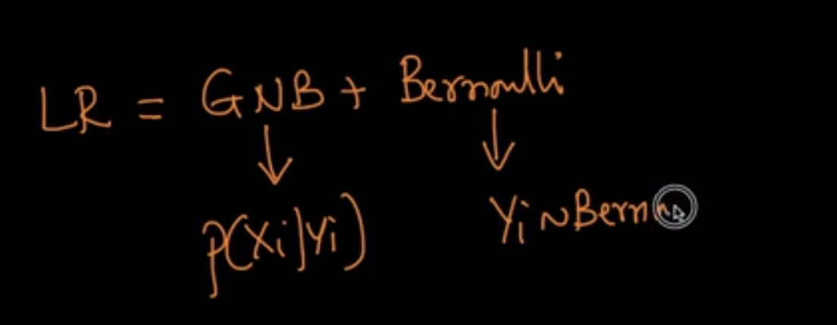  
There is one thing we need to look is there is some difference in geometric and Probabilistic equation.  
In geometry, we considered +1 or -1 for Yi but in Prob. It is considered as +1 or 0 in some text books. Equation as follows  
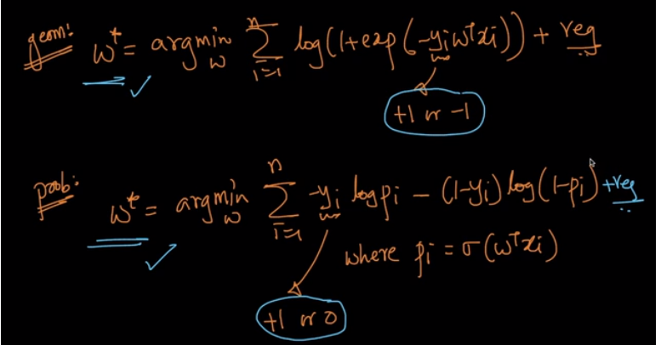  
both equations shown above are same. Explained below  
  
**Case#1**: when Yi = +ve   
Consider Yi = +1 for both the Equation. Substitute values in both the equation as below   
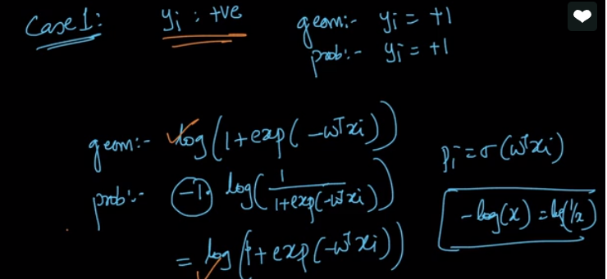  
  
**Case#2**:   
When Yi = -ve and Yi = 1 for geometric and Yi = 0 for probabilistic. Once we replace the Yi value and mathematical calculations, both equations(Geometry and prob. ) are same, pointed with red arrow.

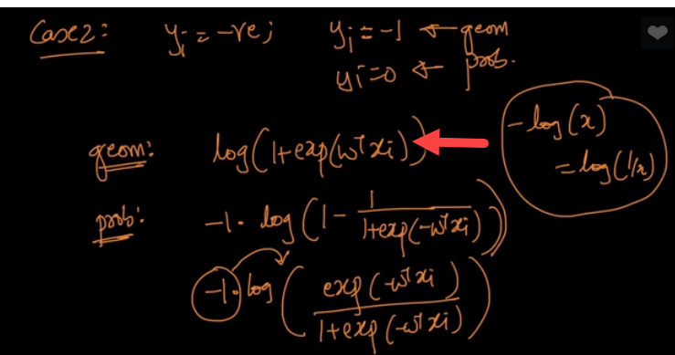  
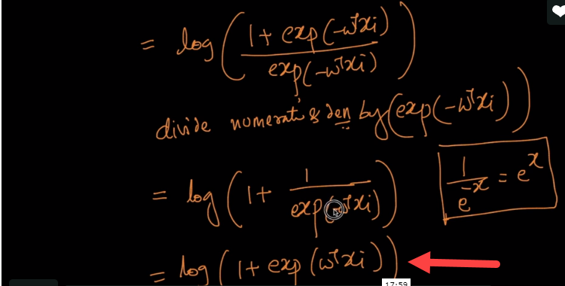  
  
  
Refer: <https://www.cs.cmu.edu/~tom/mlbook/NBayesLogReg.pdf>